Amanda Atkinson,

21688366

1.a) The maximum measured anomaly occurs directly over the dike so the equation for the maximum is:

$$∆B_{max}=\frac{200tΚ_{ m}B_{E}}{μ_{0}}\frac{z}{z^{2}}$$

The half-width of the anomaly ( $x_{1/2})$ is defined as the distance between the maximum anomaly and the point where the anomaly is ½ the maximum, which yield the following equation:

$$\frac{1}{2}∆B_{max}=\frac{200tΚ_{ m}B_{E}}{μ_{0}}\frac{z}{{{x_{1/2}}^{2}+z}^{2}}$$

Substituting $∆B_{max}$ into the half-width equation and using some algebra to solve for z, gives us the equation:

$$z=x_{1/2}$$

Which is the same result we got with gravity.

1.b) I used GNU Octave to graph my results because I lost my patience with the Java applet. Using the variables and equation established in the problem, graphed a response between x=[-1:0.0001:1]. I found the max value of the function and where the function equaled half the max value. The distance between the max value and the half max value is $x_{1/2}$, which we have proved to be equal to z in 1.a.

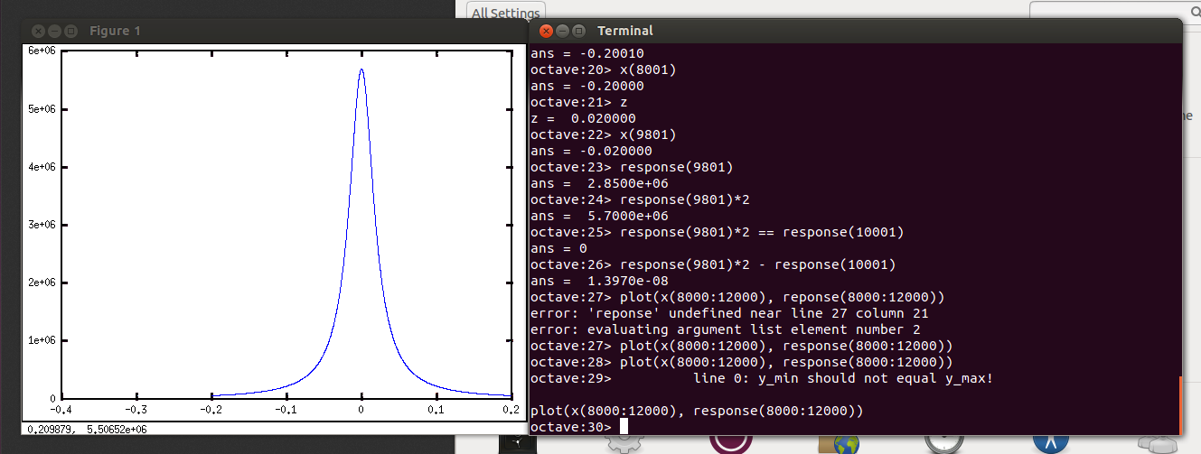1.c) I used quartic regression to establish the Regional Correction because it represents more of the shape. The true shape of the curve was closer to a Gaussian curve so I tried a quadratic regression, which was a poor fit for the data. The quartic regression fit the data much tighter. To closest match the model I saw in 1.b., I multiplied the data by -1 and subtracted the minimum. This made the data deltas instead of absolute values.

I found the max at f(x)=274.04, x=14.5 , and the half max f(x)=128.52, x=-18. Since $z=x_{1/2}$, the corrected depth of the anomaly is:

$$z=14.5-\left(-18\right)=32.5km$$

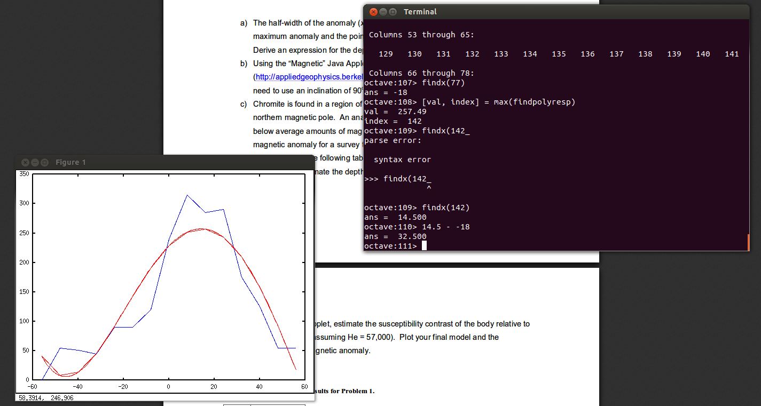

1.d) Using $B_{E}=57,000, μ_{0}=4π*{10}^{-7}$ and z=32.5 meters, estimate the susceptibility contrast of the dike relative to the background:

Applying all the data, I got a result of $Κ_{m}=-1.1061*{10}^{-9}$. This negative value makes sense because the body in question is reported to have below average amounts of magnetite compared to the background material. The final model and anomaly is plotted in magenta.

Because I didn’t subtract the mean, the width of the model might be larger than the truth, which is seen in my models.

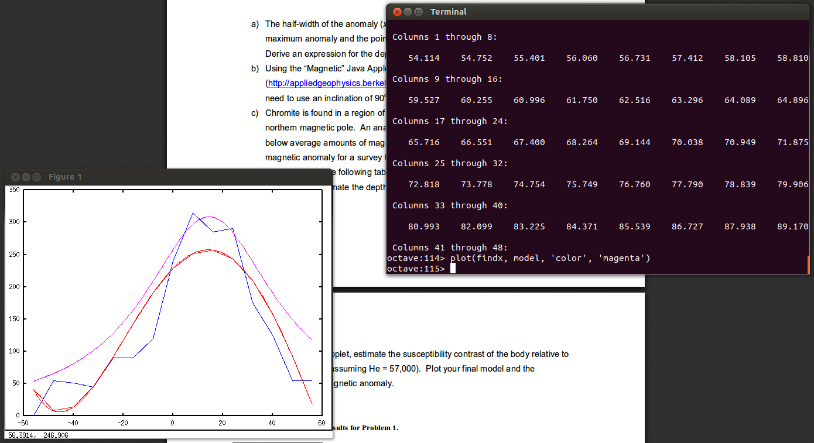

2.a) I conceded and used the lovely and extremely functional Java applet for this problem. My model shows that the smaller pit is shallower, which means that it is the younger pit. So the deeper, larger pit is older.

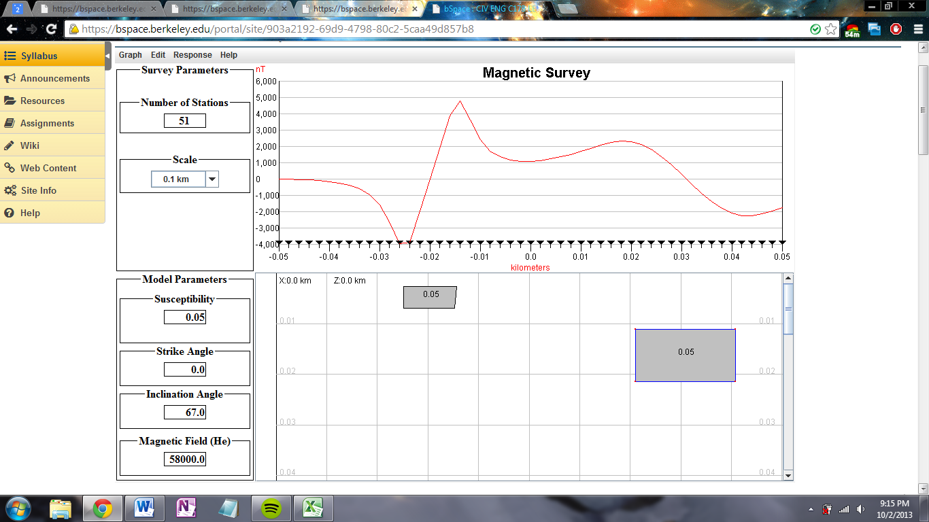

2.b) If the survey was performed near the magnetic pole, it would make the lines more like single peaks. My model sort of showed a clustering of data, making it easier to interpret.

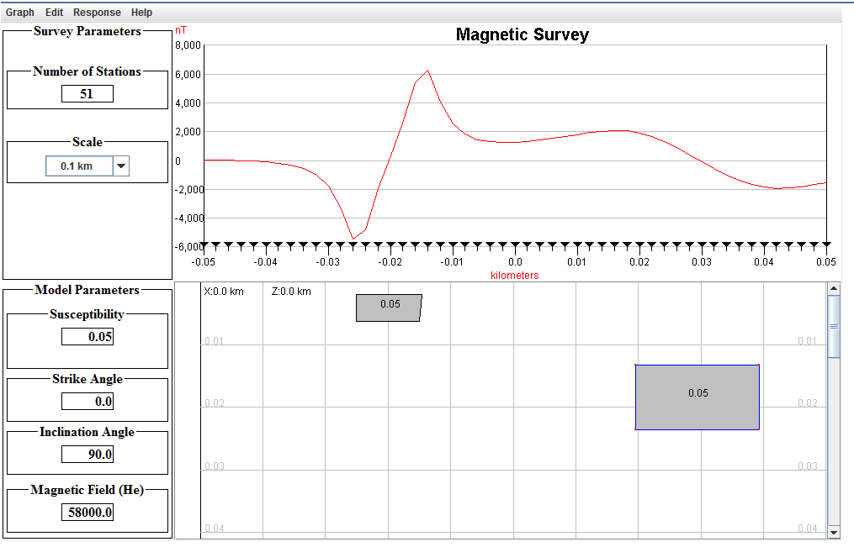

3.c) I am assuming that the equations relating B, H, J in class are referring to the same B, H, and J from the homework. Using this:

$J=kH$ $H=\frac{B}{μ} →J=\frac{kB}{μ}=\frac{kB}{\left(1+k\right)μ\text{0}}$

$J=\frac{(0.03emu)*(58,000*10\text{-9}T)}{\left(1+.03\right)(4π*10\text{-7}H/m)}$ = 1.34432 amp/m

If one accepts that the formula contains some conversion factor from $\frac{V*s}{m}→\frac{amp}{m}$.

4.d) We can use 2-D vector addition since both vectors are in the same plane.

$J_{i}=1.344$ A/m

$J_{t}=2.16$ A/m

JR

Jt

Ji

67˚

86˚

67˚